**COMP 1026**

[Student’s Name]

[Student’s ID]

Course Name:

Instructor’s Name:

Due Date**:**

**A Simple Mensuration Calculator**

***Purpose***

Purpose of this python program is to calculate the area and parameters of different types of shape and also the calculation of the summation of the n numbers.

***Working***

This program opens with the menu. User should select any of the option to continue further operations.

***Output***

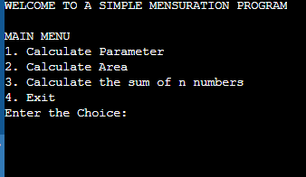

As you can see, the user is given some choice and the user is supposed to enter the choice number accordingly. For example, user inputs 3.

***Output*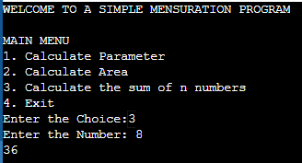**

As you can see, after the number 3 is entered by the user, program asks for the

Input of any number and after entering the number , the summation of all the numbers till the entered number is printed.

In this way ,program move forward as the user inputs the

User can exit the program by entering the 4th choice.

**Python feature used in this program:**

In this program we have used the **def** function for defining the different functions. We also used the **for loop** in the function for the summation of n numbers . We used the **If,else if and break** to make the choice thing work in the program for the flexibility of the program to make users able to enter the different choice.

Also used **while loop** to make the program run on the different choice with different conditions. We also used different **logical and arithmetic operators** in the program.

***Python code***

''' A Simple Mensuration Calculator to:

1. Find perimeter of a Circle, a rectangle or a square

2. Find area of a Circle, rectangle or square

'''

# defining functions

def p_circle(radius):

''' Takes radius as parameter and prints its

circumference.

'''

para = 2 * 3.14 * radius

print("Circumference of Circle:", para)

def p_rectangle(height, width):

''' Takes height and width of a rectangle as

parameter and prints its Perimeter.

'''

para = 2 * (height + width)

print("Perimeter of Rectangle:", para)

def p_square(side):

''' Takes side of the square and

prints its Perimeter.

'''

para = 4 * side

print("Perimeter of Square:", para)

def a_circle(radius):

''' Takes radius of the circle and

Prints it's area.

'''

area = 3.14 * radius * radius

print("Area of Circle:", area)

def a_rectangle(height, width):

''' Takes height and width as parameter

and prints it's area.

'''

area = height * width

print("Area of Rectangle:", area)

def a_square(side):

''' Takes side of a square as parameter

and prints it's area.

'''

area = side * side

print("Area of Square:", area)

# printing the starting line

print("WELCOME TO A SIMPLE MENSURATION PROGRAM")

# creating options

while True:

print("\nMAIN MENU")

print("1. Calculate Perimeter")

print("2. Calculate Area")

print("3. Exit")

choice1 = int(input("Enter the Choice:"))

if choice1 == 1:

print("\nCALCULATE PERIMETER")

print("1. Circle")

print("2. Rectangle")

print("3. Square")

print("4. Exit")

choice2 = int(input("Enter the Choice:"))

if choice2 == 1:

radius = int(input("Enter Radius of Circle:"))

p_circle(radius)

elif choice2 == 2:

height = int(input("Enter Height of Rectangle:"))

width = int(input("Enter Width of Rectangle:"))

p_rectangle(height, width)

elif choice2 == 3:

side = int(input("Enter Side of Square:"))

p_square(side)

elif choice2 == 4:

break

else:

print("Oops! Incorrect Choice.")

elif choice1 == 2:

print("\nCALCULATE AREA")

print("1. Circle")

print("2. Rectangle")

print("3. Square")

print("4. Exit")

choice3 = int(input("Enter the Choice:"))

if choice3 == 1:

radius = int(input("Enter Radius of Circle:"))

a_circle(radius)

elif choice3 == 2:

height = int(input("Enter Height of Rectangle:"))

width = int(input("Enter Width of Rectangle:"))

a_rectangle(height, width)

elif choice3 == 3:

side = int(input("Enter Side of Square:"))

a_square(side)

elif choice3 == 4:

break

else:

print("Oops! Incorrect Choice.")

elif choice1 == 3:

break

else:

print("Oops! Incorrect Choice.")